COMP90018 Mobile Project Final Report
Group Number: Tutorial 8 - Group 2
Project Title: FitQuest – Gamified Health and Fitness App

Section 1: Team Information
Name | Student ID | Email
Yiyao Li | 1166330 | yiyao3@student.unimelb.edu.au
Kaicheng Liang | 1598744 | kaichenglian@student.unimelb.edu.au
Chong Shi | 1547056 | choshi1@student.unimelb.edu.au
Qingbo Tan | 1589385 | qingbot@student.unimelb.edu.au
Yu Luo | 1528667 | yuluo9@student.unimelb.edu.au

Section 2: Link to Demonstration Video

Section 3: Instruction to Compile and Run
3.1 Prerequisites
This application currently supports iOS devices and simulators only. Android is not supported currently. To run this application, you need to make sure you have following items installed:
- macOS (required for iOS development)
- Node.js 18+ and npm
- Python 3.9+
- Xcode (for iOS simulator)
- Firebase project with Authentication and Firestore enabled (create your own Firebase API key)
- Expo CLI: npm install -g @expo/cli

3.2 Backend Setup
# Navigate to backend
cd backend

# Create virtual environment
python -m venv venv
source venv/bin/activate # Windows: venv\Scripts\activate

# Install dependencies
pip install -r requirements.txt

# Configure Firebase
# 1. Place firebase_service_account.json in backend/config/
# 2. Create backend/config/.env with:
# FIREBASE_API_KEY=your_key
# FIREBASE_PROJECT_ID=your_project
# CORS_ORIGINS=*
# FATSECRET_CLIENT_ID=your_id (optional)
# FATSECRET_CLIENT_SECRET=your_secret (optional)
We have already uploaded our API key in the direction in github repo, you can ignore this step
# Start server
uvicorn app.main:app --host 0.0.0.0 --port 8000 --reload
Backend will run at http://localhost:8000
3.3 Front Setup
# Navigate to frontend
cd frontend

# Install dependencies
npm install

# Configure environment
# Create frontend/.env with:
# BACKEND_URL=http://localhost:8000
# For physical device, use your machine's IP:
# BACKEND_URL=http://192.168.1.10:8000

# Start dev server
npx expo start –go

# Run on iOS device/simulator
npx expo start --ios # iOS simulator (macOS only)
# Or scan QR code with Expo Go app on physical iOS device (make sure you have Expo go on your iphone/ipad)

Section 4: Terminal Screenshots
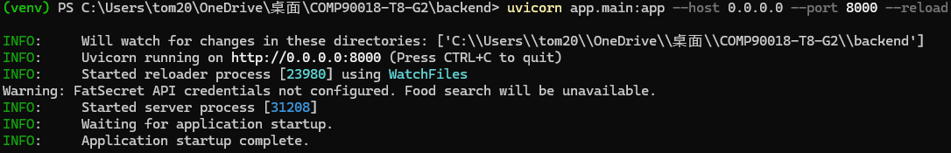
Backend screenshot

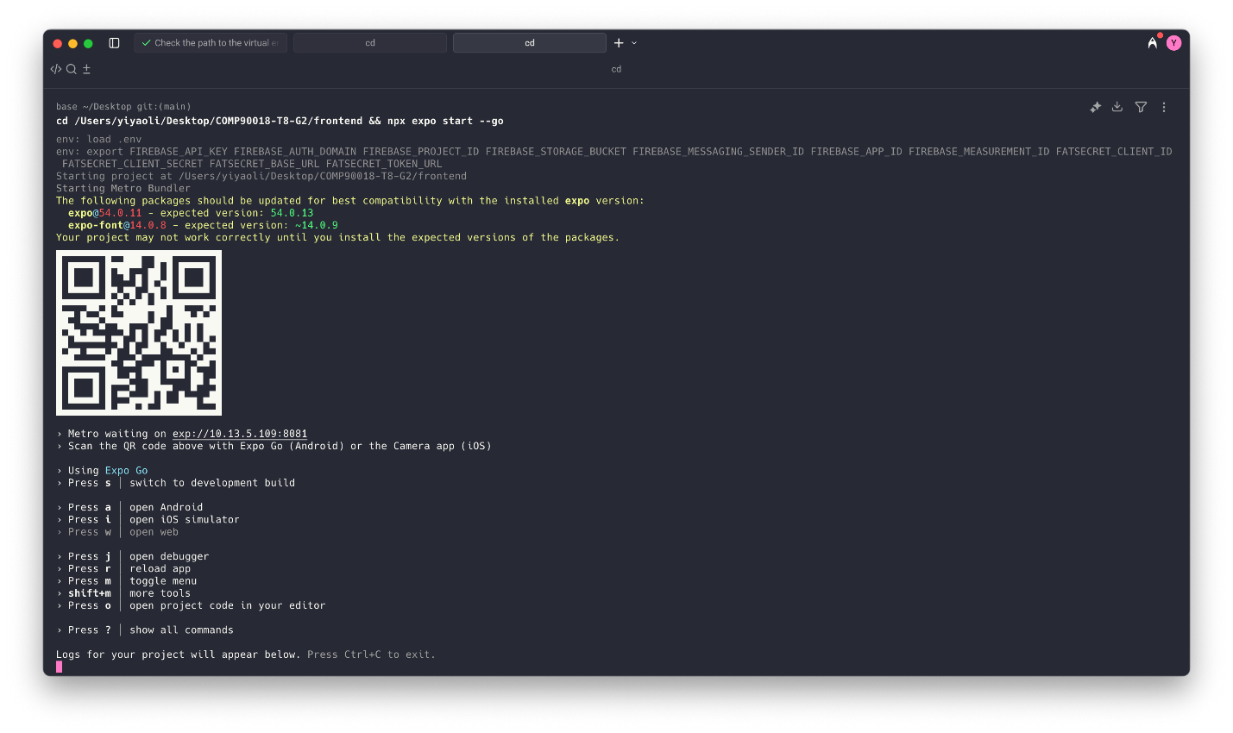
Frontend screenshot

Section 5: Students’ Contribution

Section 6: How We Met Rubric Criterion
6.1 Report & Video
We intend to deliver a comprehensive and well-structured project report that covers the following key aspects:
    - Link to a demonstration video which covers comprehensive functionalities in the application and clear showcases and instructions of all features in our app;
    - A demonstration video showcasing the UI and core interactions, recorded via Expo;
    - Clear instructions to set up and run backend and frontend respectively and key prerequisites before setting up all the things;
    - Two terminal screenshots (backend and frontend) show the information when starting the application successfully;
    - Organized and clear contribution of each students, with detailed accomplishments of every team members;
The report is written in an highly organized Word documentation, covering all aspects that required, with clear details. Coupled with the demonstration video, this submission aims to achieve exceptional quality in both content and presentation.

6.2 Screenshots
Our submission will include two screenshots to clearly showcase the information when starting (interpreting) the backend and the frontend. All information showing the application is started successfully is shown in two screenshots, providing a checkable reference when starting the application.

6.3 Commit log
We adopt GitHub for project version control and enforce a collaborative development workflow with the following practices:
    - Each team member develops in a dedicated branch corresponding to different functional modules (e.g. module related to food/workout) ;
    - Two different functional modules are strictly segregated, ensuring that changing code of one functional module will not affect the other one;
    - Commits are clearly labeled using standardized messages (e.g., feat, bugfix, docs), clearly summarizing the changes in one submission;
    - Branches of different functionalities are integrated into the main branch only after we make sure they have no bugs, reducing the changes and merge conflicts in main branch.
A complete commit history can be checked on git repo, serving as traceable evidence of the development process and individual participation.

6.4 Itemised contributions
We have outlined a detailed division of contribution for each team member in the report, including:
    - Primary ownership of specific functional modules;
    - Detailed work of each functional modules;
    - Measure the importance level of each one’s work, whether their code is runnable (avoiding submitting huge amount of void code)
    - Level of participation in project progress (on a weekly basis, including coding, communication, document writing, etc.).

6.5 Quality
To ensure maintainability and scalability, the system has been decomposed into multiple modular components, each developed and tested independently. The current implementation includes the following core modules:
- Food Tracking Module:
Allows users to record their daily meals either by scanning barcodes (using Expo BarcodeScanner) or by manual input. The system automatically parses and displays nutritional data such as calories and macronutrient composition. Users can also set their daily calorie intake goals, also can record intake of breakfast, lunch, and dinner respectively.
- GPS Route Tracking Module:
Utilizes Expo Location to capture geospatial data, recording users’ walking or running routes, duration, average speed, and providing an estimated calorie expenditure feature.
- Virtual Pet Collection Module:
Acts as a motivational system. When users complete a certain amount of exercise, they will receive a blind box reward that unlocks a random virtual pet. Users can view both collected and locked pets within the interface and choose which pet to display on the home screen.
- Login/Register Verification Module:
Provides user authentication and registration functionality. During registration, users must submit a valid email address to receive a confirmation link from the system; registration is only completed once the link is verified. The system ensures that only authenticated users can access all APIs and interactive features.
- Home Screen Module:
Serves as the central control dashboard, displaying the selected pet, food intake records, and today’s exercise summary. It also provides quick access to core modules such as food logging and workout tracking. The design emphasizes a consistent and user-centric experience.
All modules are developed collaboratively and tested rigorously to ensure accurate data handling and smooth user interactions. The project follows Continuous Integration and iterative team-based development, aiming to achieve high implementation quality standards.

6.6 Sensors
The application integrates two core hardware sensor modules and coordinates their operation through dedicated APIs to ensure efficient interaction and data flow:
- GPS Location Sensor (via Expo Location):
Continuously captures real-time geolocation data to track user movement. The frontend system records the user’s location in real-time to compute metrics such as total duration and average speed. These location data points are periodically sent to the backend to record the user’s route, which can be reviewed later.
- Camera-based Barcode Scanner (via Expo BarcodeScanner):
Uses the device camera to scan food barcodes and matches them with a cloud-based food database. Once identified, the system automatically fills in key nutritional details such as food name, calories, and major nutrient components, improving the accuracy and convenience of dietary tracking.
All data collected from sensors are uploaded to Firebase Firestore for cloud storage. These data are related to other features differently. Running activities recorded via GPS contribute to progress toward earning the next blind box based on the distance covered. Similarly, scanned food entries synchronize with the “Healthy Eating” goals and daily nutrition dashboard.
This integration ensures stable sensor data input and establishes a closed-loop interaction flow, allowing hardware data to be directly transformed into meaningful in-app actions and enhancing the overall user experience.

6.7 Connectivity
The backend architecture is built on the Firebase platform, meaning all collected data are uploaded to Firebase servers. This setup enables seamless connectivity, data consistency, and real-time interaction across all layers of the application:
- User Authentication and Security:
Implemented using Firebase Auth with an email/password login system. Only verified email addresses can register, and users must be logged in to access interactive features, ensuring persistent sessions and secure data access.
- Real-time Data Synchronization:
Firestore’s onSnapshot() listener is used to reflect real-time updates to food records, allowing immediate UI feedback and state consistency.
- Asynchronous Data Communication:
All data read and write operations are handled through Firebase’s asynchronous APIs, ensuring low-latency access and seamless synchronization across multiple devices.
- Data Recording and Storage:
For example, when a running session is uploaded, the backend processes and merges GPS data received from the frontend, storing the aggregated record in the remote Firebase database.
This architecture establishes a clear flow of data collection → data processing → data persistence, demonstrating a high level of system connectivity and consistency, and providing a solid foundation for the application’s real-time responsiveness and scalability.

6.8 Responsiveness
The frontend of the application is developed using React Native and Expo, with a strong focus on delivering a highly responsive, visually engaging, and accessible user experience. To achieve smooth and seamless interactions, several optimization strategies have been implemented:
- Real-time Location Updates via Expo Location:
The frontend leverages Expo Location to capture and update users’ movement paths in real time, allowing location information to be instantly displayed on the interface and enhancing both interactivity and accuracy.
- Responsive Layout Design:
Through a Flexbox-based layout and adaptive font/component scaling, the interface maintains consistent aesthetics and usability across various screen sizes (phones, tablets) and platforms (iOS/Android), in compliance with accessibility standards.
- Smooth Navigation Transitions:
The navigation structure is built using React Navigation, combining Top Tab Navigator and Stack Navigator to deliver intuitive and fluid page transitions while preserving state consistency across views, ensuring a cohesive user experience.
- Robust Exception and Permission Handling:
In cases of missing permissions (e.g., GPS or camera) or network issues, the system displays appropriate notifications to inform users of the problem, guide them through corrective actions, and maintain interface consistency and usability.
These design decisions collectively form a highly responsive frontend architecture, achieving tight synchronization among functionality, data updates, and user interactions, while ensuring both responsive design and operational stability.

6.9 Technical depth
The system is built upon a set of advanced mobile and cloud technologies, combined with a well-structured and organized project directory, reflecting strong technical capability and architectural coherence:
- Authentication and Cloud Data Modeling:
Firebase Auth and Firestore are used to implement secure user authentication and establish persistent cloud-based data structures for storing activity records, health settings, and user profiles.
- Real-Time Frontend–Backend Synchronization:
Bidirectional communication between the frontend and backend ensures instant state updates (e.g. meal logging, run completion), while a long-polling interaction mechanism enables stable data recording during users’ activity sessions.
- Lightweight Frontend–Backend Architecture Design:
The frontend and backend are fully decoupled. Frontend is built with the React framework, achieves fast startup, seamless navigation between modules, and quick responsiveness to user actions.
The backend, developed with Python FastAPI, provides lightweight RESTful API queries, minimizing backend complexity while maintaining high responsiveness and efficiency.
- Sensor-Integrated Real-World Mapping:
By integrating camera-based barcode scanning and GPS route tracking, the system accurately transforms real-world behaviors into in-app data, delivering a contextual and immersive health experience.
These technical components encompass comprehensive frontend and backend development, real-time state management, and sensor data processing. All of these represent challenging aspects of mobile application development.
The team is dedicated to addressing these complexities through scalable and maintainable solutions, demonstrating exceptional technical proficiency and systematic design thinking.

6.10 User Interface – Appeal
FitQuest adopts a minimalist interface design complemented by a vibrant and welcoming color palette, aiming to create an easy and direct interactive experience. The user interface is clean and well-organized, with a clearly defined top navigation bar that provides access to the app’s main functional areas, including:
- Clear and Organized Home Screen:
The homepage presents several key sections: daily calorie intake and target goal, total distance exercised for the day, the currently selected virtual pet for display, and the number of blind boxes owned. Each element is displayed in a concise and intuitive layout, allowing users to quickly grasp their overall progress.
- Detailed Food Information Interface:
The page is neatly divided into several sections showing total daily calorie intake, macronutrient breakdown (carbohydrates, fats, proteins), and calories consumed at breakfast, lunch, and dinner. The interface uses a simple and cohesive color scheme, offering users a clear and well-structured overview of their nutritional data throughout the day.
- Intuitive Exercise Interface:
The lower section of the page features a clear goal indicator and a “Start Running” button, along with weekly exercise mileage tracking. After tapping “Start Running,” users are redirected to the workout tracking screen, which displays a GPS map at the top and key metrics such as total distance, average speed, and elapsed time below. The entire flow is designed with a clean and intuitive UI for effortless user interaction. The overall design ensures a straightforward, visually clean, and responsive workout experience.
- Comprehensive Summary Screen:
The summary page gives users a clear overview of their daily fitness performance, including total distance, calories consumed, and calories burned. It also provides a timeline view of past workouts, enabling users to track their progress over time and reflect on their fitness journey in a visually consistent layout.
This visual style is carefully crafted to appeal to young, health-conscious users, combining comprehensive fitness-related functionality with a simple and intuitive aesthetic to enhance daily engagement and overall user satisfaction.

6.11 User Interface – Guidelines
The application’s user interface (UI) design strictly follows iOS platform design standards, ensuring a consistent and intuitive user experience across different iOS devices. The key design features include:
- Material Design-Compliant Touch Feedback:
All buttons and touch areas abide the Material Design guidelines, ensuring responsive interactions, user-friendly touch zones, and an enhanced tactile experience.
- Keyboard and Form Compatibility:
Input areas, such as dietary logs, support multiple keyboard layouts and languages, with smooth auto-focus and keyboard dismissal logic, ensuring a seamless input experience.
- Unified Navigation Structure:
Using React Navigation with a combination of Top Tab Navigator and Stack Navigator, the app maintains a consistent and logically structured navigation flow (as seen in the top tabs “Food” and “Run”). Each page transitions to only one or two subpages, preventing confusion from overly deep navigation hierarchies.
- Platform-Adaptive Interactions:
UI elements such as modals, dropdowns, and gestures (e.g., swipe-to-close on iOS) behave in ways consistent with platform-specific conventions, aligning with user expectations.
- Design System Implementation:The app features a comprehensive design system with standardized color tokens (including an aurora gradient palette for data visualization), typography hierarchy (dual-font system), spacing scales, and reusable component styles managed through React Native's StyleSheet API.
These design decisions ensure optimal usability, interaction consistency, and ease of onboarding, minimizing user confusion and significantly enhancing the app’s overall quality and professional appeal.

6.12 User Interface – Flow
After successful registration and login, users are directed to the main interface, where they can easily access core functions including meal tracking, exercise recording, and summary pages.
- On the Food page, users can view and edit their calorie intake and see the calories for breakfast, lunch, and dinner.
- On the Run page, users can tap the “Start Run” button to begin tracking their workout, then press “Finish” on the GPS screen to end and save the record.
- On the Summary page, users can review their past exercise and meal records.
The entire user flow has been carefully designed and visualized in Figma flowcharts, and the frontend follows this blueprint closely to ensure a clear, consistent, and easy-to-use interaction process.
All navigation transitions and feature connections have been thoroughly tested to maintain a high level of consistency and usability.

6.13 User Interface – Language
The app interface is presented entirely in English, focusing on clarity, action-oriented language, and emotional expression. The main strategies include:
- Action-Oriented Labels:
All interface texts (such as “Start Run,” “Log Meal,” “Finish”) use clear action verbs to indicate what the user should do, reducing confusion.
- Functional Prompts:
Each section includes short English hints explaining its purpose (for example, “Complete running goals to earn more!” showing the users how to get more blind boxes), helping users understand the interface easily.
- Consistent Grammar Style:
Text elements use simple verb phrases and avoid long or vague sentences, keeping the language clean, direct, and consistent across the app.
- Error and Exception Messages:
In special cases (such as “Network connection lost” or “Location permission required”), the system provides clear and easy-to-understand English notifications to guide users.
This language design combines clarity with a slightly playful tone, improving both user understanding and overall interaction experience.
6.14 User Interface - Reactiveness
The application focuses on real-time responsiveness and smooth interaction, ensuring that every user action feels instant and natural.

When users finish a workout and tap the “Finish” button, the system immediately moves to the summary page, clearly showing the workout results, including distance, time, and average speed. At the same time, the system automatically generates a real-time visual GPS map of the running route and displays it on the screen. Each workout update (e.g., total distance) instantly adds progress toward unlocking the next blind box.

Similarly, updates to food intake are shown instantly on the “Food” page, where users can see their calorie and nutrition goals in real time.
When checking past fitness or food logs, selecting a specific date quickly retrieves and displays data from the database, thanks to the lightweight backend and Firebase’s fast response to simple data queries.

Overall, the design ensures seamless, lag-free transitions between visual and functional elements, providing users with a highly responsive, clear, and immersive interaction experience.

6.15 Innovation – Novelty
FitQuest introduces several innovative design elements that not only having the single-purpose nature of traditional health tracking apps, but also aiming to create a more fun and personalized experience for users. Its main innovation lies in combining a gamified collection system with everyday health management.
- Gamified Pet Collection System:
Unlike typical fitness apps that only record data, FitQuest links users’ healthy activities directly to earning virtual pets. Each completed run adds progress toward unlocking a blind box, which gives users a chance to collect new and unique pets. This creates a positive emotional loop that motivates users to keep exercising.
- Pets as Rewards:
The app features a variety of cute and cool-looking pets that appeal to different user preferences. Collecting these pets provides a sense of achievement, especially for users who enjoy collecting items. While real fitness results take time to appear, this reward system turns users’ efforts into visible, short-term satisfaction, keeping them motivated and engaged.

6.16 Innovation – Surprise
FitQuest redefines how health data is presented, turning it into a fun and mysterious collection experience that adds unexpected depth. This design brings a sense of surprise and joy, helping the app stand out from other health and fitness applications.
- The thrill of not knowing what comes next:
As mentioned in the previous section, when users fill up their blind box progress bar, they can open a box to receive a random, previously locked pet. Since users never know which new companion they’ll get, this sense of mystery motivates them to keep exercising in order to collect all their favorite pets.

6.17 Innovation - Tech Knowledge
This project demonstrates a strong integration of key concepts and practical skills in the field of Computing and Information Systems, as outlined below:
- Front-end Development:
The application uses React Native for modular UI development and state management, integrated with Firebase to achieve real-time synchronization and cross-module data persistence. This shows a solid understanding of modern front-end architecture.
- Back-end Architecture:
The system is built with Python FastAPI, a lightweight and fast framework, together with Firestore for cloud-based data infrastructure. The backend defines and manages schema structures (e.g., food, workout, users) to control user access and ensure proper data modeling, demonstrating strong skills in NoSQL database design and access management.
- Sensor Integration:
The project integrates Expo Camera and GPS modules to enable barcode-based food logging and location-based workout tracking. Combined with Firebase Functions for real-time nutrition data processing, this reflects the team’s proficiency in asynchronous programming and cloud-triggered computation.
- Data Visualization: The app presents health and fitness data through a card-based interface with progress bars, circular indicators (using react-native-svg), and real-time metric displays. Running routes are visualized using interactive maps (react-native-maps), providing clear and immediate feedback on user activity and progress.
Overall, this system covers multiple key areas, client interaction, cloud integration, data modeling, and visualization, reflecting the team’s technical competence and ability to integrate complex system components effectively.

6.18 Innovation - Cross-Disciplinary
This project combines principles from multiple disciplines beyond computer science and applies them through engineering practice, including:
- Integration of Nutrition Science:
Concepts such as Basal Metabolic Rate (BMR) and calorie balance are applied in the barcode recognition and nutrition database system. This enables real-time calculation of macronutrients like carbohydrates, proteins, and fats, helping users make healthier and more informed dietary choices.
- Psychological Motivation Design:
Inspired by behavioral psychology, the system includes instant rewards, blind box draws, and visual goal-setting features within the gamified task flow to increase user engagement and motivation over time.
- Human-Computer Interaction Design:The app employs touch-based interactions with visual feedback through TouchableOpacity components, animated elements (breathing effects for virtual pets, particle systems for interactions, and shake/reveal animations for reward systems), and pull-to-refresh gestures to create a responsive and engaging user experience.

6.19 Innovation – Impact
The application is designed for long-term use, aiming to help users to achieve measurable improvements in their daily eating habits and overall health. It mainly impacts:
- Habit formation and health awareness:
By combining meal logging with exercise tracking, the system builds a complete personal health profile for each user. Through continuous feedback and historical record tracking, users can identify and adjust unhealthy patterns, improving self-awareness and developing sustainable healthy habits.
- Structured feedback loop:
The system creates a clear motivational cycle — “workout completed → progress accumulated → blind box reward → new pet unlocked.” By embedding habit formation into small interactive moments, the app can provide users with a sense of mental satisfaction, encouraging them to stay active and motivated.

